Nama : Afad Fath Musyarof Halim  
NIM : 2211104030  
Kelas : S1SE-06-01

Screenshot running Flutter   
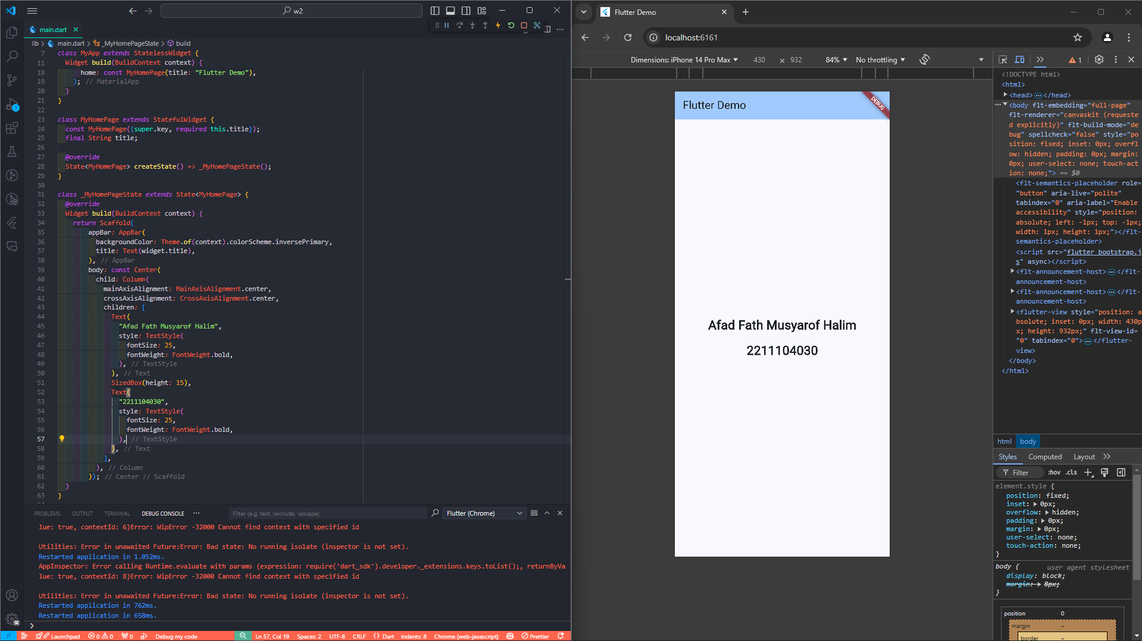

Soal Tambahan

* Code  
  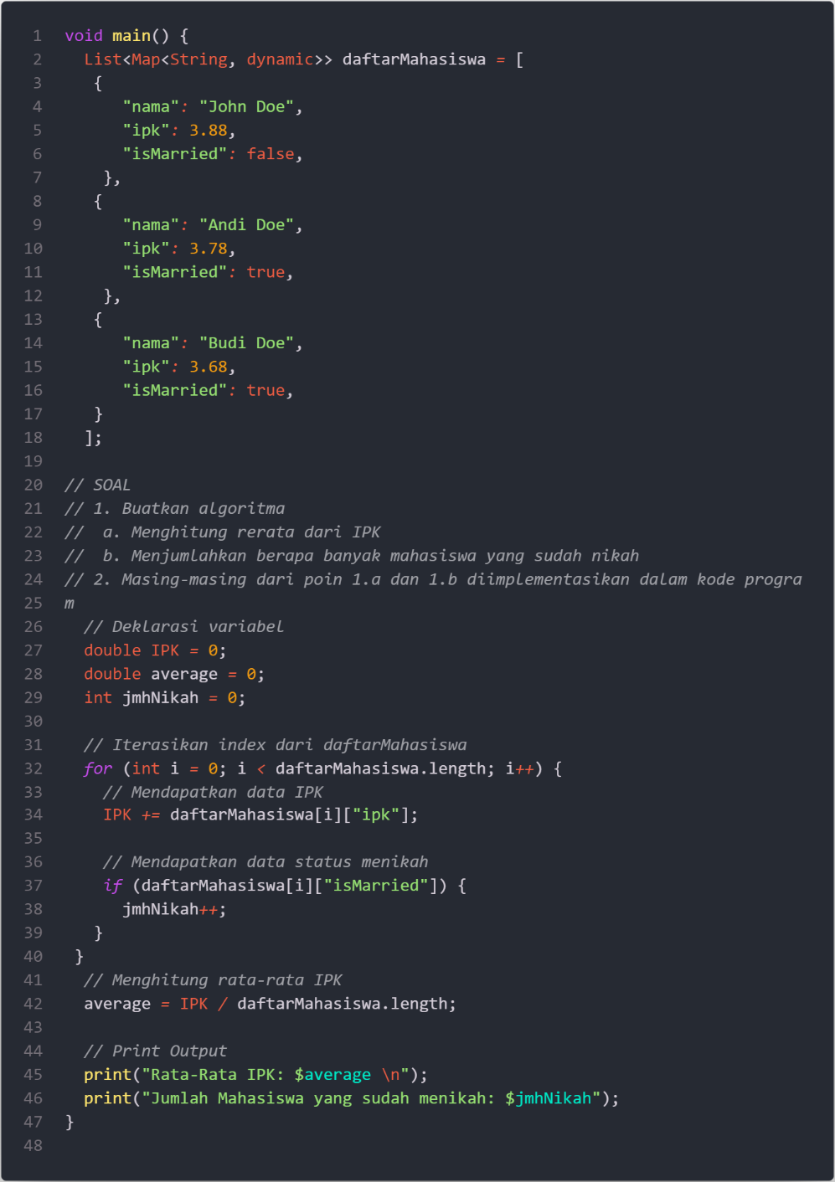
* Running  
  